**GETTING STARTED WITH DITA USING OXYGEN XML EDITOR**

**INDEX:**

**1. DITA INTRO 3**

**2. Getting Started with DITA 4**

1.1 DITA Topics 4

1.2 DITA Maps 5

1.3 DITA Maps Manager 5

**3 . Steps to create and publish a DITA map using OXYGEN XML editor 6**

3.1 Switch to the DITA UI perspective 6

3.2 Create a map 7

3.3 Create, edit and add topics to the map 7

3.3.1 Create a generic map 8

3.3.2 Add topics to map 9

3.3.2.1 add a new topic to a map 9

3.3.2.2 Adding existing topic reference 11

3.3.2.3 Fast Create Multiple DITA Topics 12

3.3.3 Converting the type of the topics inserted 14

3.3.4 Inserting tables 15

3.3.5 Adding related links of a topic within other topic 16

3.3.6 Adding cross reference 17

3.3.7 Displaying tags of each line in a topic 19

3.3.8 Adding steps in a topic 19

3.3.9 Adding list items 20

3.3.10 inserting images 20

3.3.11 inserting video 24

3.3.12 Adding critical dates like “created” 25

3.4 Validate and check for completeness 25

3.5 Publish 27

# DITA INTRO

DITA is an XML standard, an architectural approach, and a writing methodology, developed by technical communicators for technical communicators. It provides a standardised architectural framework for a common structure for content that promotes the consistent creation, sharing, and re-use of content. Some of the benefits of using DITA include the following:

**• Flexibility** - DITA is a topic-based architecture and it offers flexibility in content organization.

**• Modularity** - DITA allows for content reuse that saves time and reduces the number of modifications.

**• Structured Authoring** - DITA offers a standardized, methodological approach that helps to reduce authoring time and improve consistency.

**• Single-Source Publishing** - DITA provides the ability to change content in one place and have the change propagate everywhere.

**• Multiple Output Formats** - DITA supports multiple types of output.

**• Inheritance** - The DITA inheritance model makes it easy to specialize topics or elements within topics and you only have to define how the element is different from its immediate ancestor.

**• Process Automation** - DITA offers various ways to automate processes, such as with index or glossary production, output delivery, validation, and more.

**• Specialization** - DITA allows you to define your own information types and semantic elements/ attributes to suit the needs of your particular content model.

**• Multi-Lingual** - DITA is a translation-friendly structure that supports numerous languages and text encodings.

**• Conditional Profiling** - DITA supports conditional text processing and profiling to filter content in the publishing stage.

# Getting Started with DITA

The information in this topic is meant to be a very basic starting point for those who are just getting started using DITA in Oxygen XML Editor. Oxygen XML Editor makes it easy to create, edit, manage, and publish DITA content, but it requires at least some basic DITA knowledge. To truly get the most out of Oxygen XML Editor and all of its DITA-related features, you should explore resources in the online DITA community to acquire knowledge of its concepts and uses

## 1.1 DITA Topics

It is important to understand the role that a DITA topic plays in a DITA project. A DITA topic is not associated with a single published document. It is a separate entity that can potentially be included in many different books, help systems, or websites. Therefore, when you write a DITA topic you are not writing a book, a help system, or a website. You are writing an individual piece of content. This affects how you approach the writing task and how Oxygen XML Editor works to support you as you write.

Most of your topics are actually related to other topics, and those relationships can affect how you write and handle things such as links and content reuse. Oxygen XML Editor helps you manage those relationships. Depending on how your topics are related, you can use the tools provided in Oxygen XML Editor, along with the features of DITA, in a variety of ways.

## 1.2 DITA Maps

The basic method that DITA uses to express the relationship between topics is through a DITA map(on page 3419). Other relationships between topics, such as cross references, generally need to be made between topics in the same root map. DITA uses maps to determine which topics are part of any output that you create. While customized DITA solutions can use other mechanisms, generally DITA is not used as a way to publish individual topics. Output is created from a map and includes all the topics referenced by the map.

A publication is not always represented by a single map. For instance, if you are writing a book, you might use a submap to create each chapter and then organize the chapters in a main root map to create the book. This helps you to manage your content, offers the possibility of reusing submaps, and segregates content to support multiple people working on the same project.

## 1.3 DITA Maps Manager

Oxygen XML Editor provides a view for managing and editing DITA maps. The DITA Maps Manager view presents a DITA map as a tree or table of contents. It allows you to navigate the topics and maps, make changes, and apply transformation scenarios to obtain various output formats. By default, it is located to the left of the main editor. If the view is not displayed, it can be opened by selecting it from the Window> Show View menu.

The DITA Maps Manager includes a variety of useful actions to help you edit and organize the structure of your DITA maps and topics. The actions that are available and their functions depend on the type of nodes that are selected in the DITA Maps Manager. If you select multiple sibling nodes, the result of the actions will be applied to all the selected nodes. If you select multiple nodes that are not on the same hierarchical level, the actions will be applied to the parent node and the child nodes will inherit certain attributes from the parent node

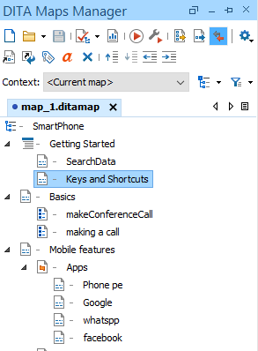

# 3 . Steps to create and publish a DITA map using OXYGEN XML editor

Imagine DITA projects were construction projects...

**Construction plan Agenda**

1. Prepare the construction site : **Switch to the DITA UI perspective**

2. Lay the foundation : **Create a map**

3. Lay bricks : **Create, edit and add topics to the map**

4. Perform quality control inspections : **Validate and check for completeness**

5. Open the finished site to the public : **Publish**

## 3.1 Switch to the DITA UI perspective

● An Oxygen XML Editor perspective is an interface layout geared towards a specific use.

● The DITA perspective provides an editing environment with default side-views and toolbars that are optimal for working with DITA projects

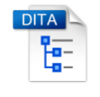

## 3.2 Create a map

● DITA maps are documents that organize topics (and other resources) into structured collections of information.

● A map is like a table-of-contents, but much more than that.

● Oxygen XML Editor provides a specialized view for managing DITA maps: the DITA Maps Manager

## 3.3 Create, edit and add topics to the map

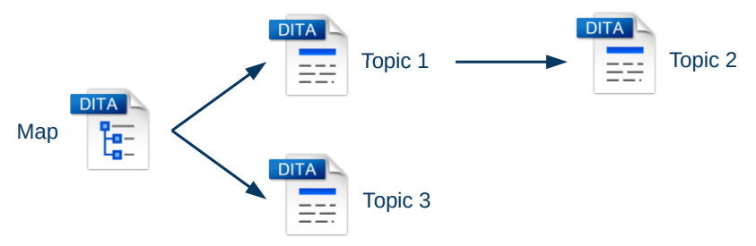

● DITA topics are the basic units of DITA content.

● Each topic should contain a single subject.

● Oxygen includes a very advanced out-of-the-box support for DITA authoring.

●The basic building block for DITA information is the DITA topic. DITA provides a variety of specialized topic types, the most common of which are:

* **Topic** - The base topic type from which all other topic types are specialized. Typically, it is used when a more specialized topic type is inappropriate.
* **Task** - For procedural information such as how to use a dialog box.
* **Concept** - For general, conceptual information such as a description of a product or feature.
* **Reference** - For reference information.

### 3.3.1 Create a generic map

* + by using File🡪new

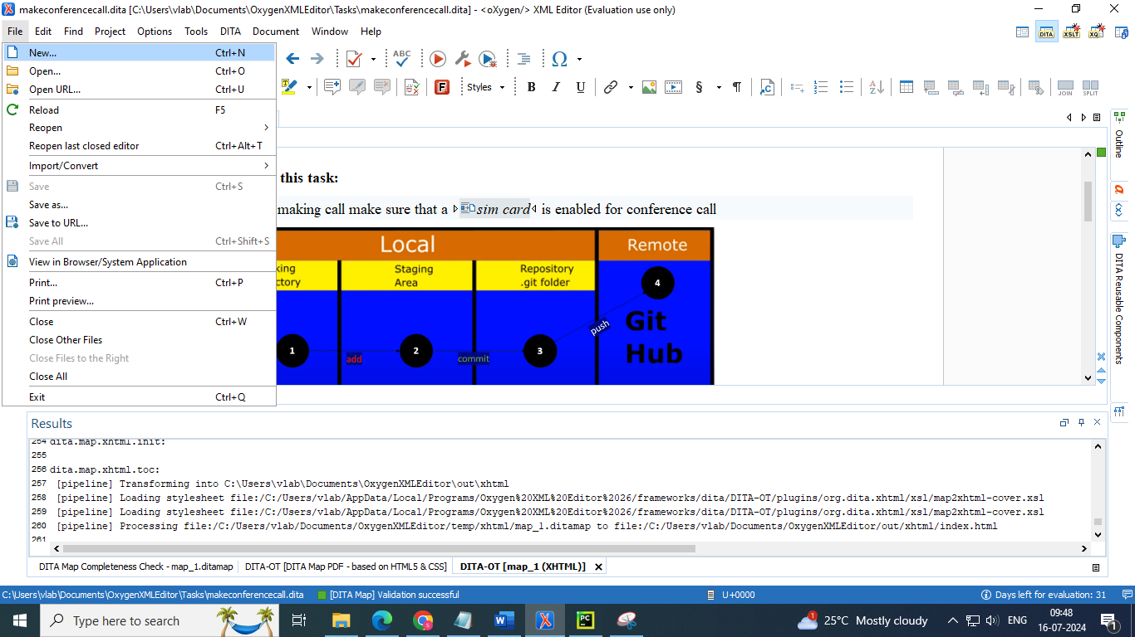

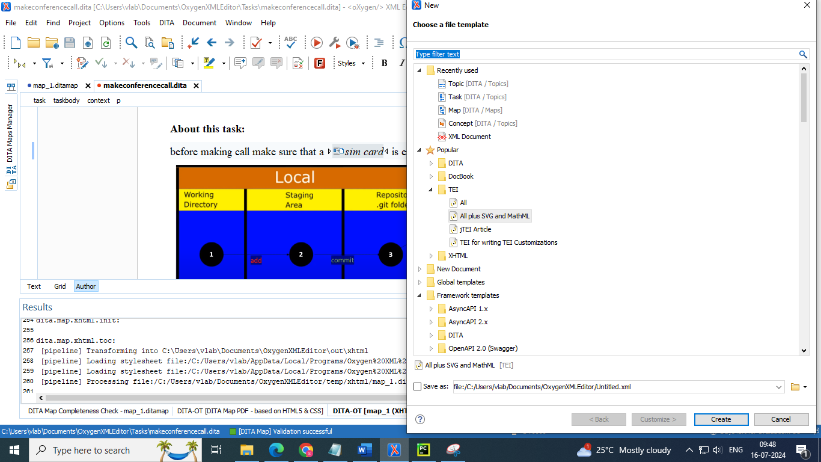

### 3.3.2 Add topics to map

#### 3.3.2.1 add a new topic to a map

follow these steps:

1. In the DITA Maps Manager , right-click the node in the current map where you want to add the new topic.
2. Select one of the following actions:
   * **Append Child >** New - Select this action to insert the new topic as a child of the selected node. This action opens a New file dialog box that allows you to select the type of document and assists you with naming it. After you have configured your new topic, click Create.
   * **Insert Before >** New - Select this action to insert the new topic as a sibling to the current node, before it. This action opens a New file dialog box that allows you to select the type of document and assists you with naming it. After you have configured your new topic, click Create.
   * **Insert After >** New - Select this action to insert the new topic as a sibling to the current node, after it. This action opens a New file dialog box that allows you to select the type of document and assists you with naming it. After you have configured your new topic, click Create.
   * **Duplicate -** Select this action to create a copy of the selected topic and insert it as a sibling. This action opens a dialog box that allows you to choose the file name and location for the newly created copy of the topic. After you have selected the name and path for your new topic, click OK.
3. Save the DITA map

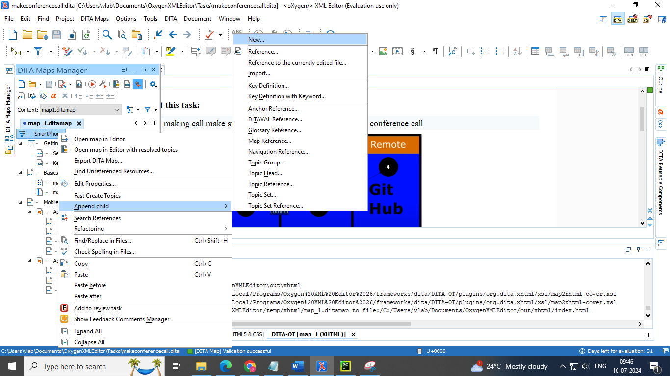

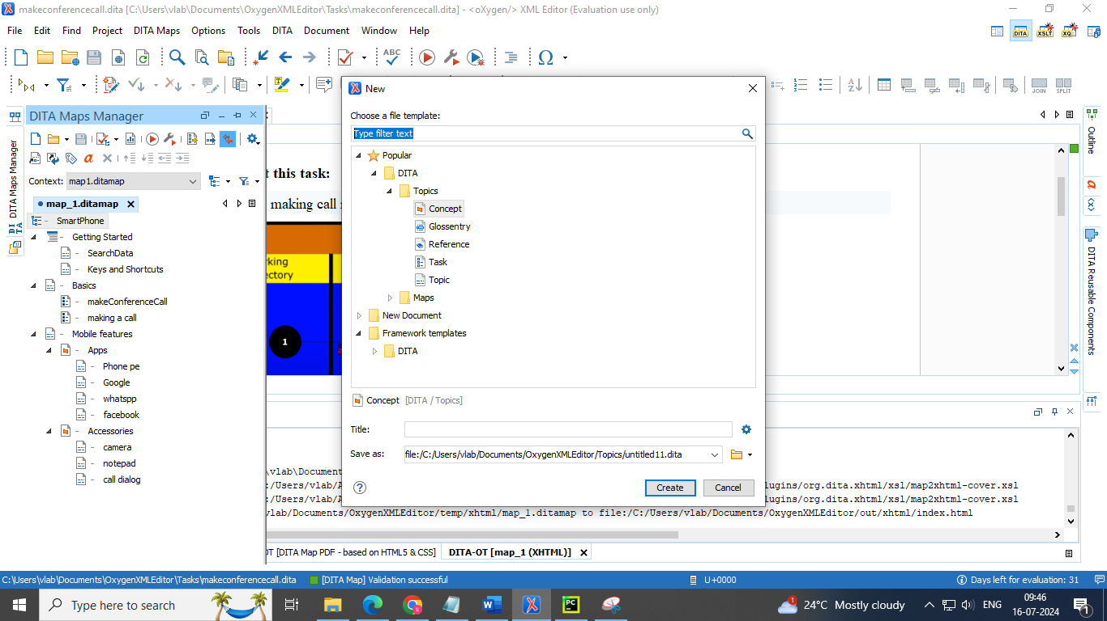

#### 3.3.2.2 Adding existing topic reference

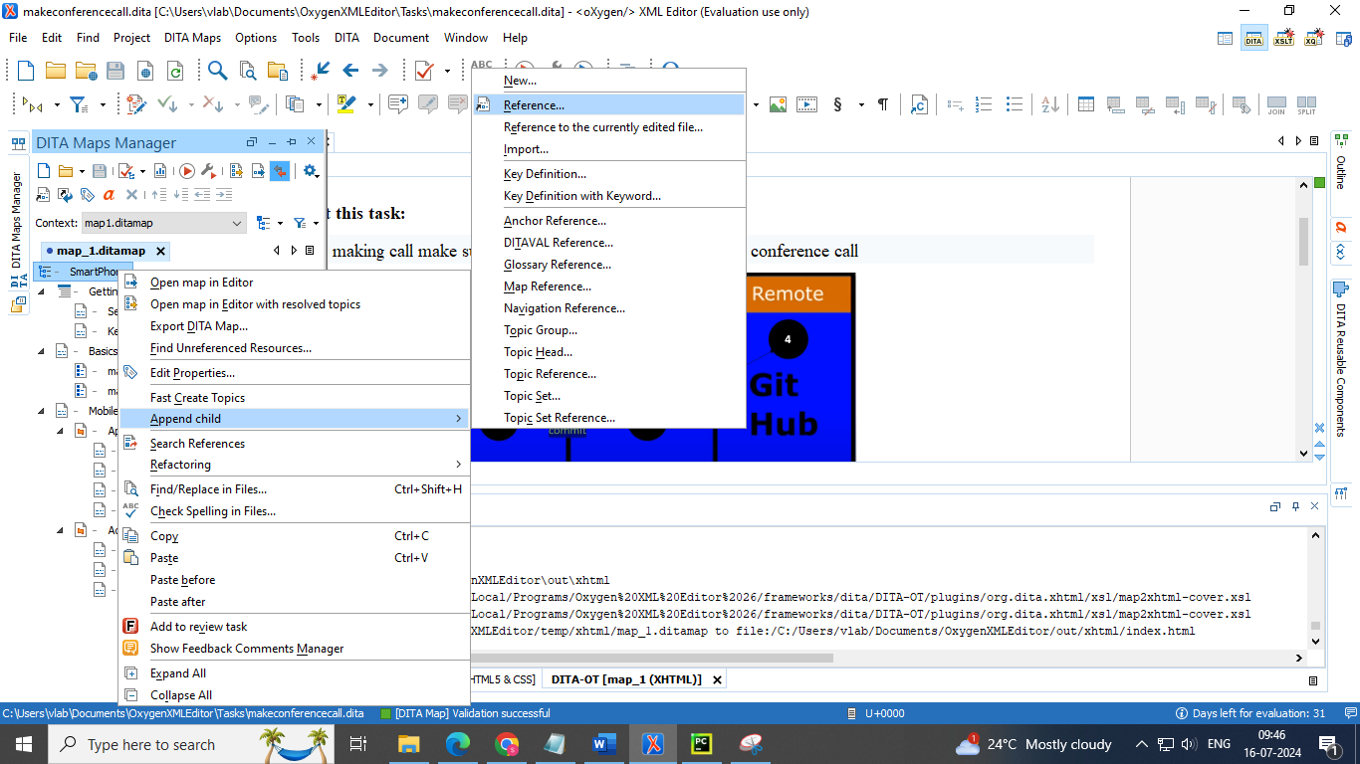

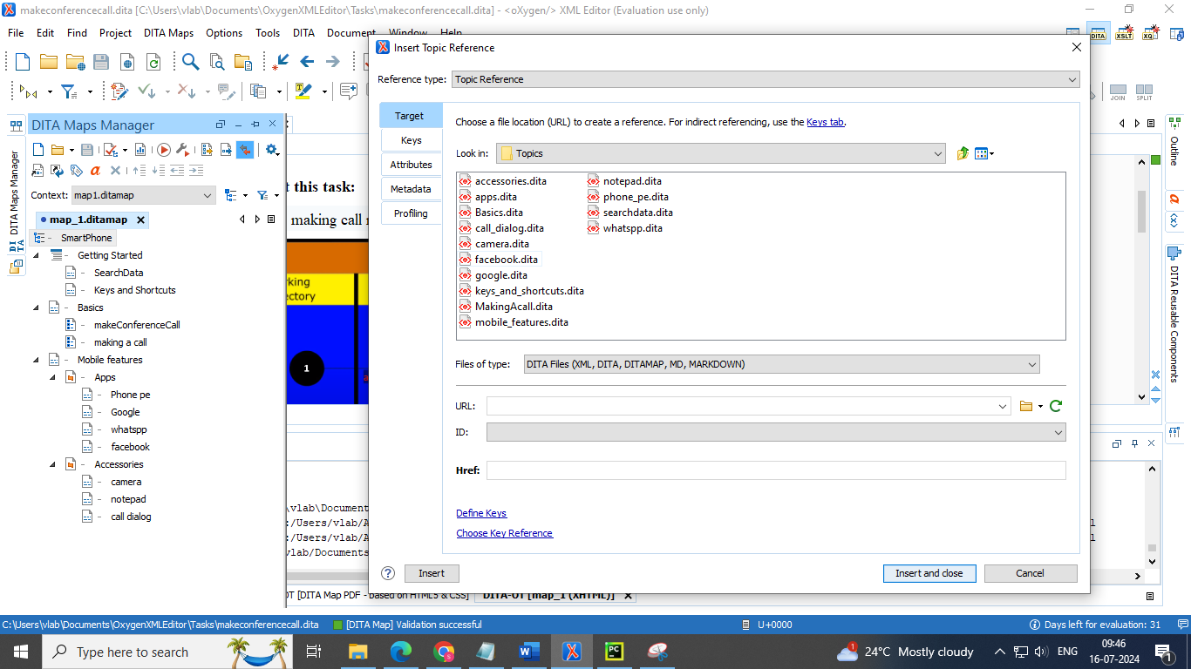

#### 3.3.2.3 Fast Create Multiple DITA Topics

The DITA Maps Manager includes a feature that allows you to quickly create multiple skeleton topics at once and you can specify their hierarchical structure within the DITA map. A common use-case for using this feature is when you need to insert a new chapter or section that will include multiple topics and you have the structure and titles planned out in advance

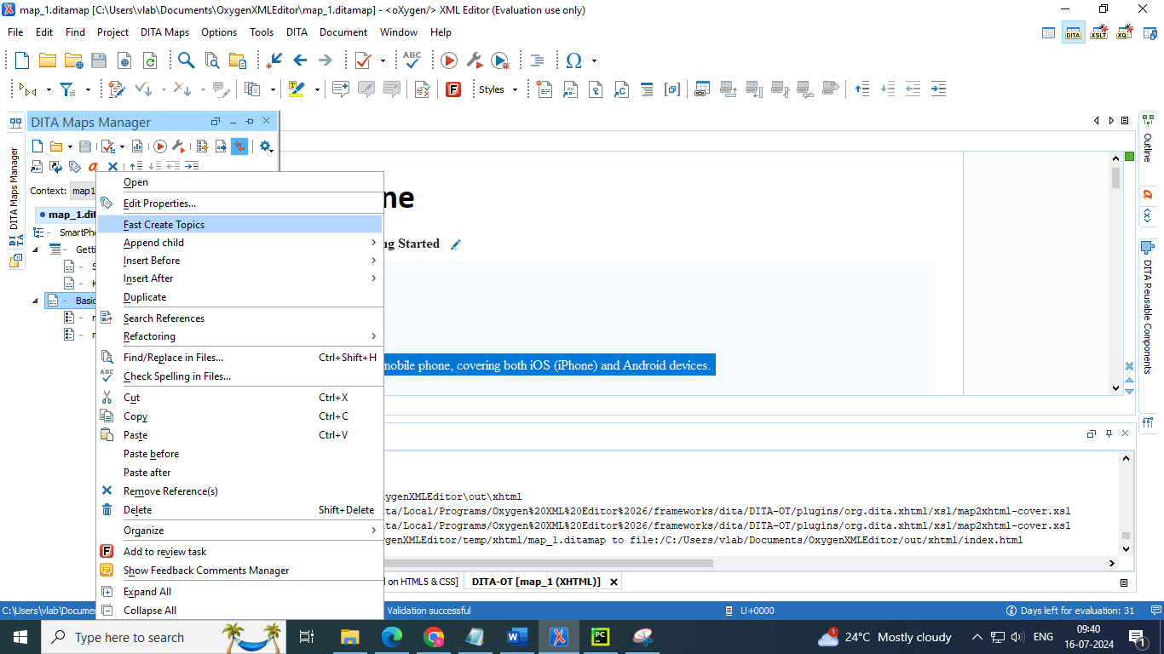

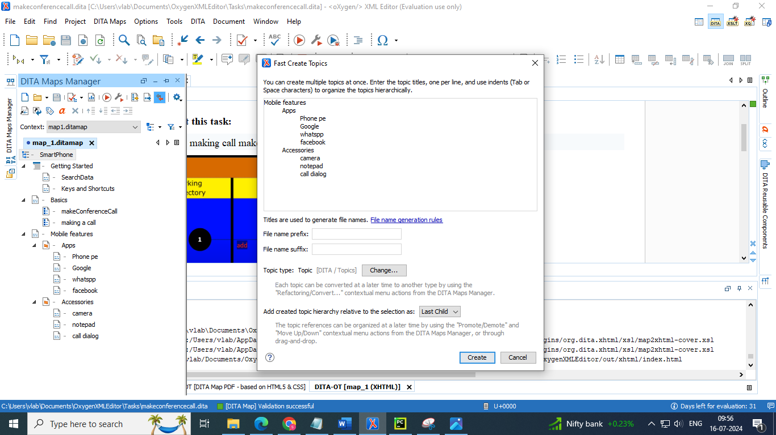

### 3.3.3 Converting the type of the topics inserted

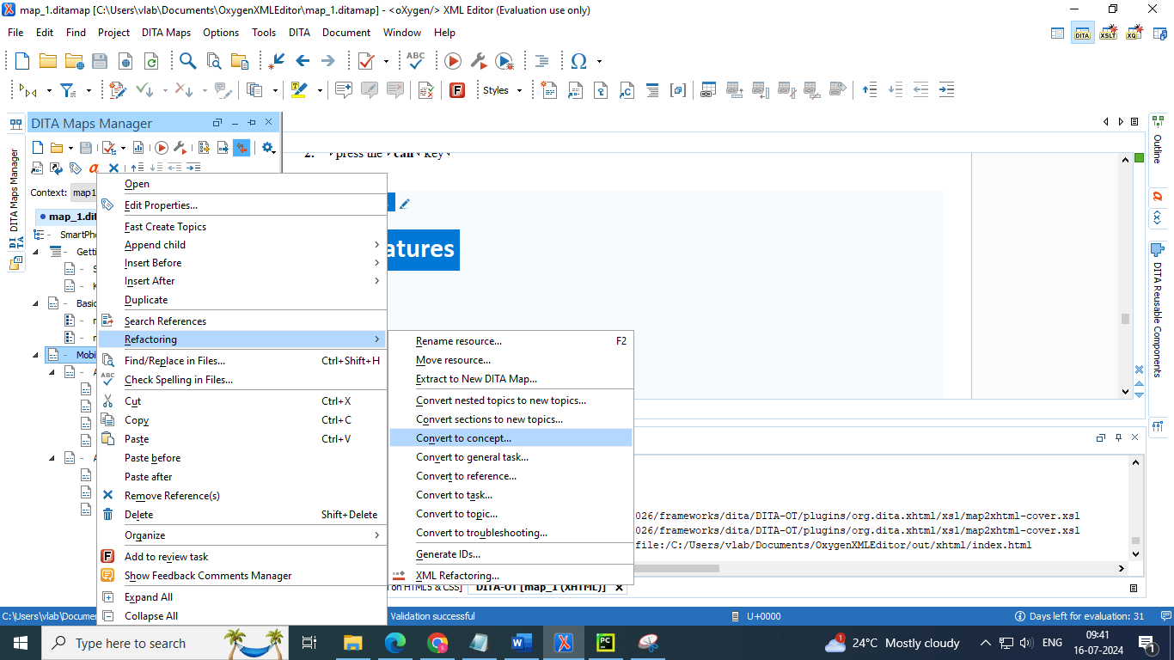

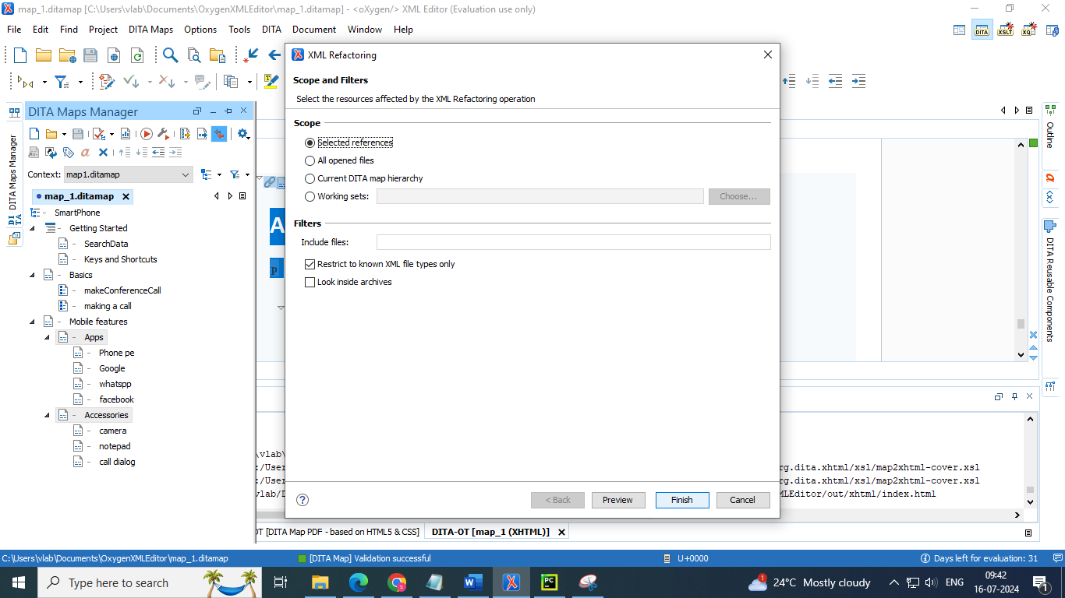

### 3.3.4 Inserting tables

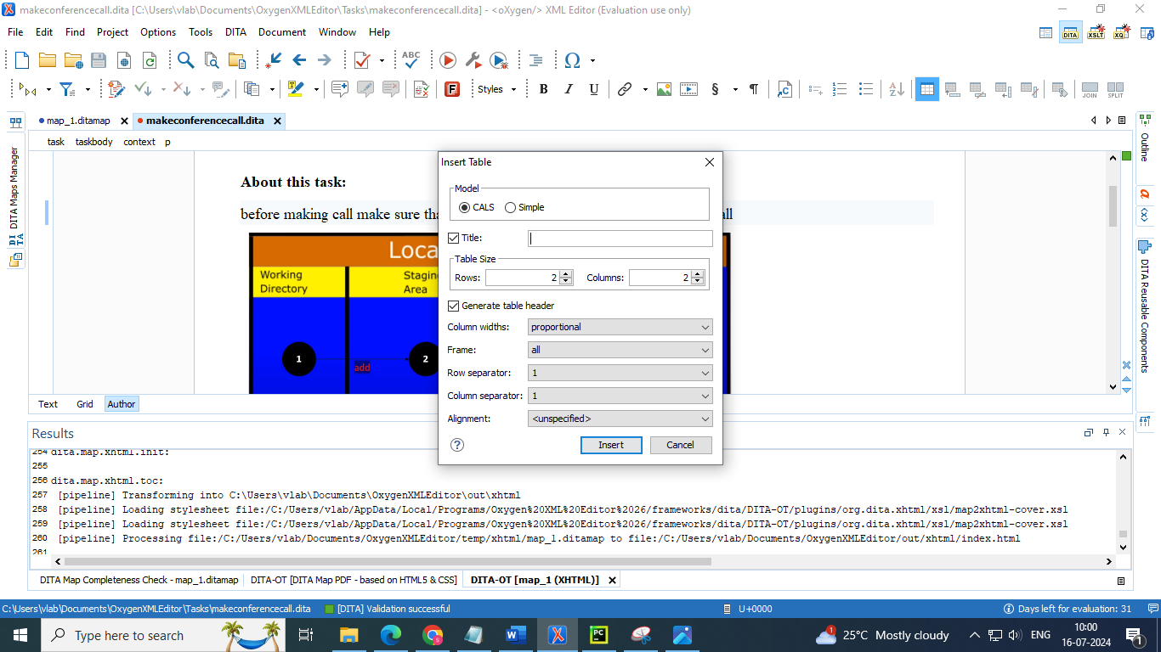

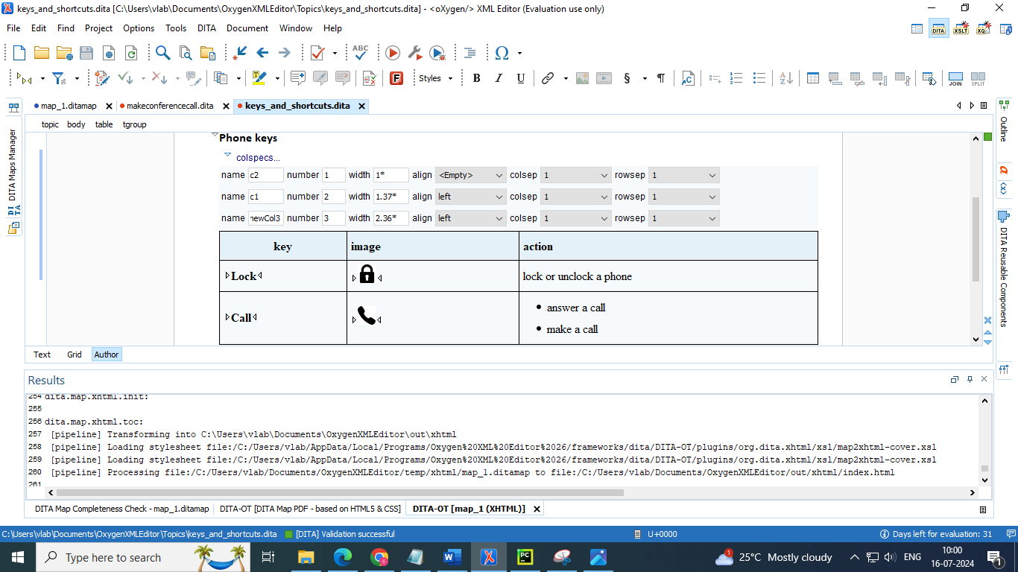

* There are some tools for table manipulation



* Create table
* Delete
* Insert
* Table properties
* Join
* Split

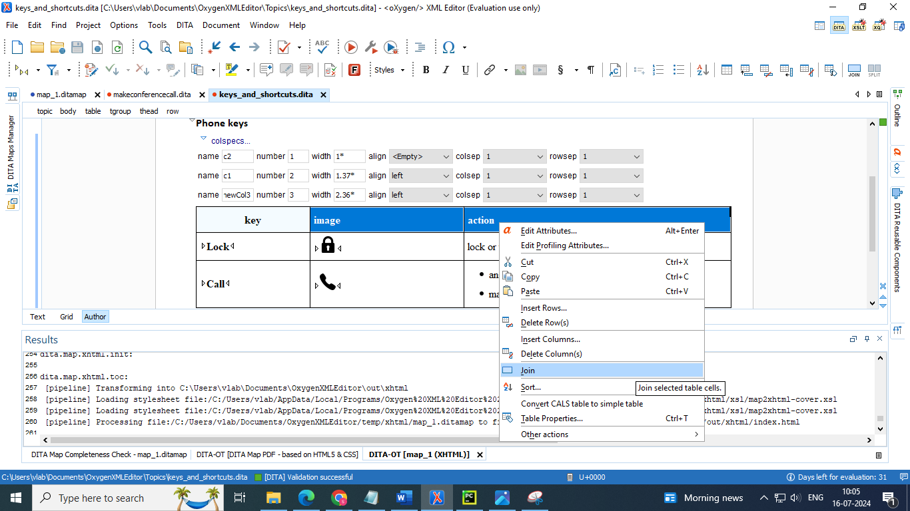

### 3.3.5 Adding related links of a topic within other topic

* We can select this feature through options for menu bar (or)
* We can drag and drop the topics whose links we want in a particular topic

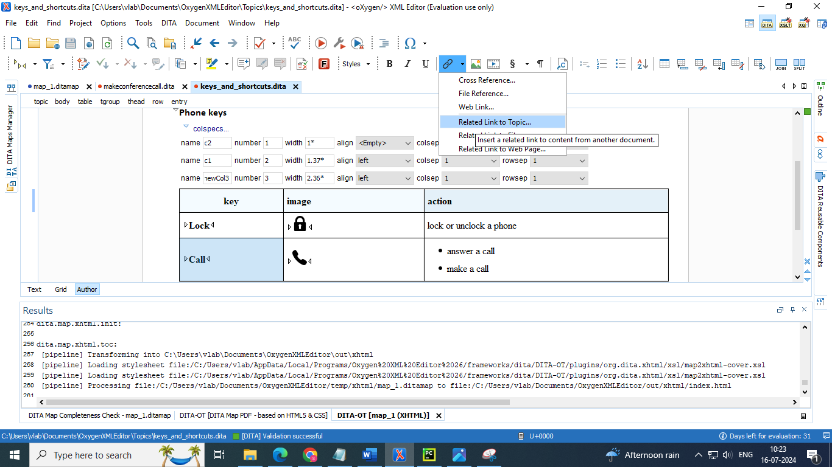

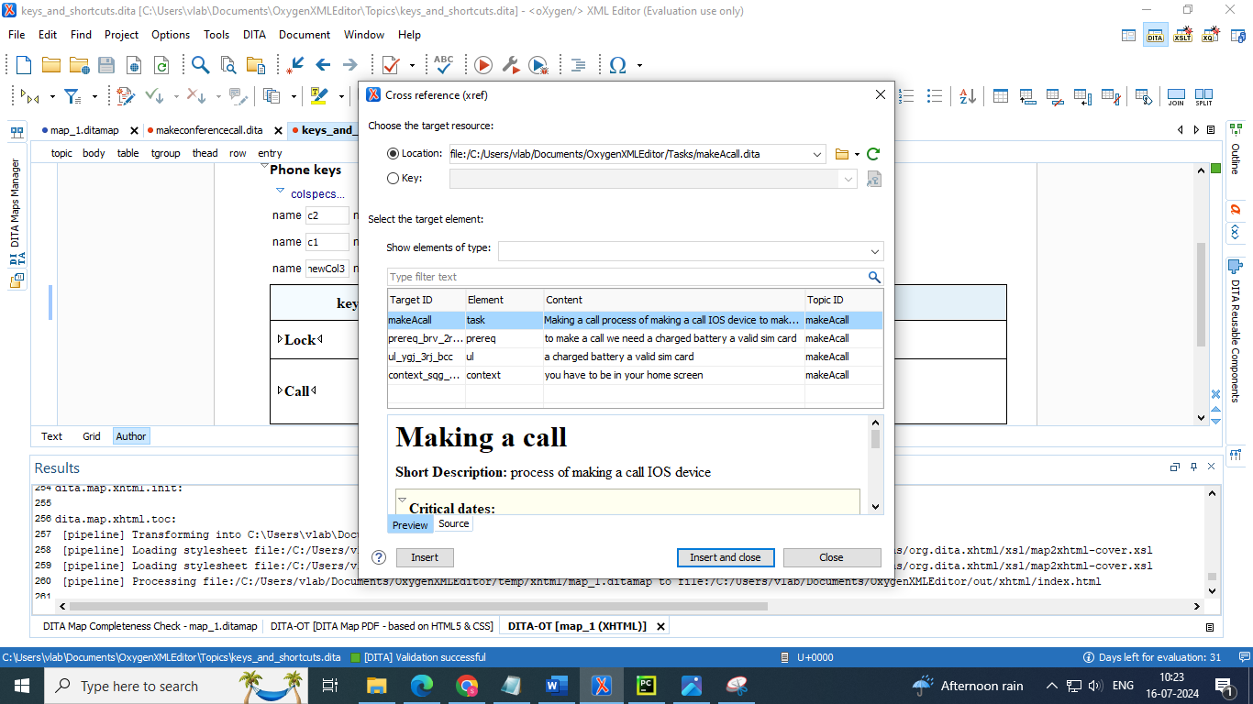

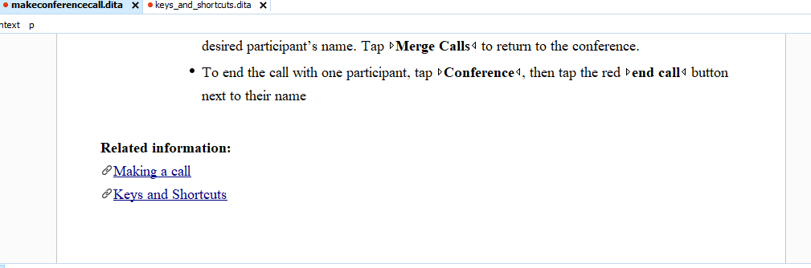

### 3.3.6 Adding cross reference

* By clicking a particular word in a topic , it opens the related defined topic by that name

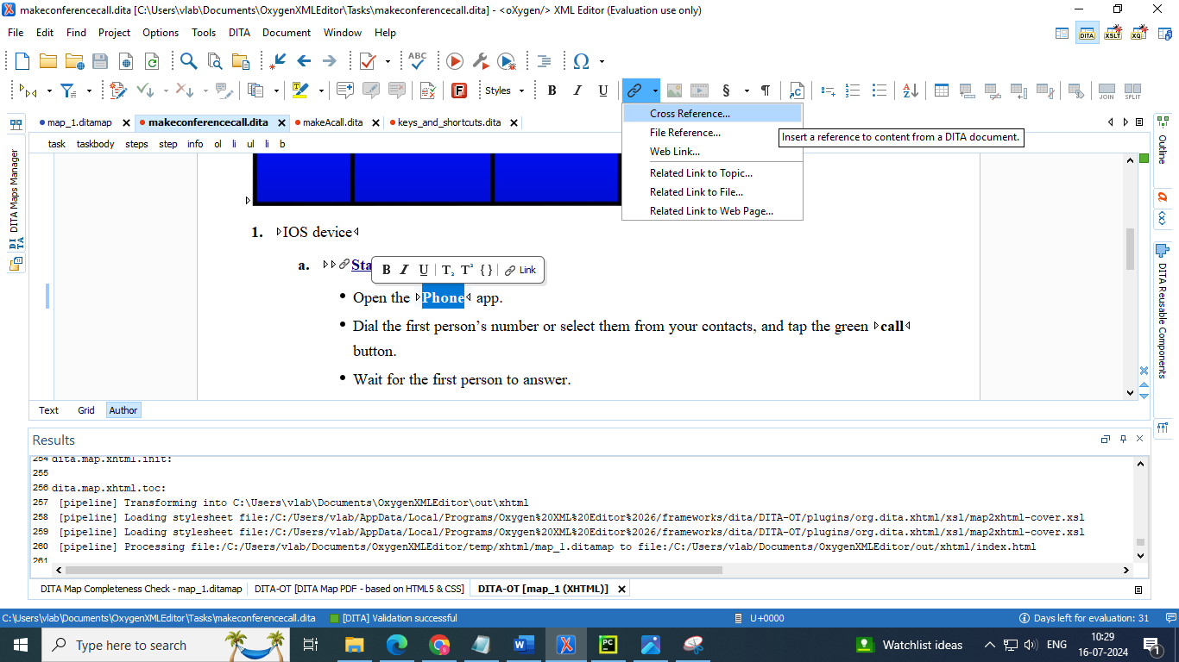

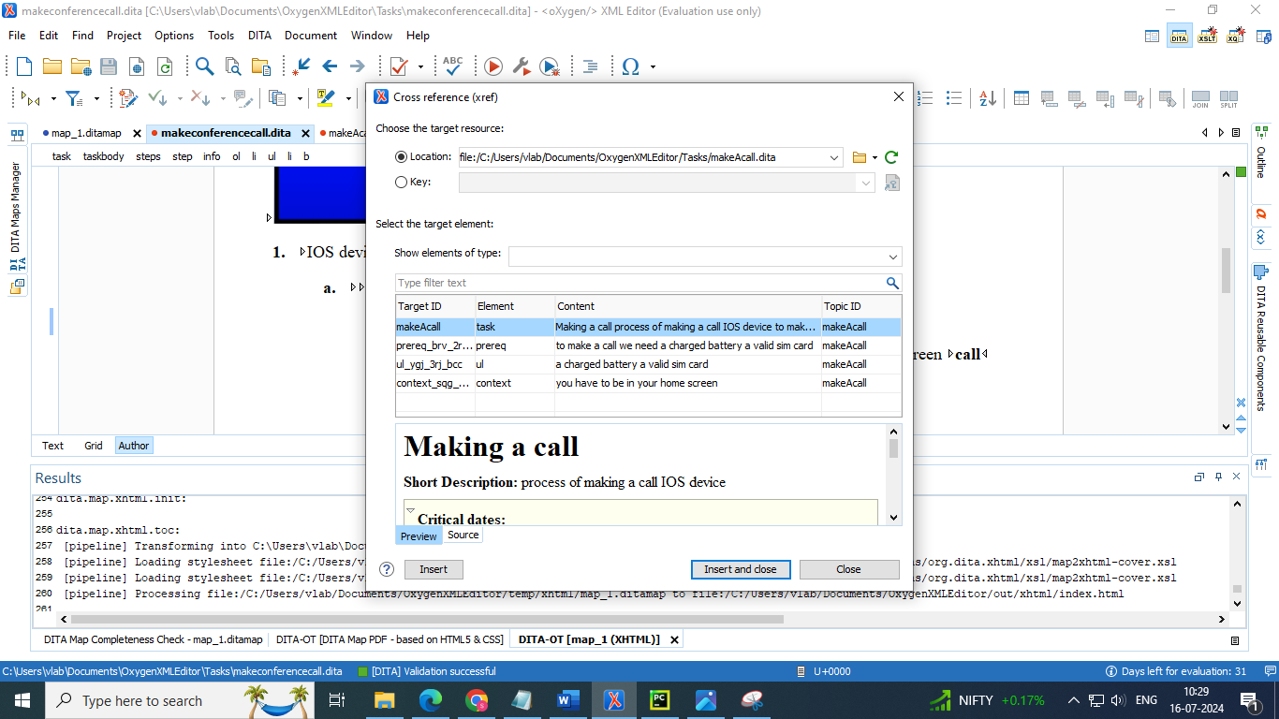

### 3.3.7 Displaying tags of each line in a topic

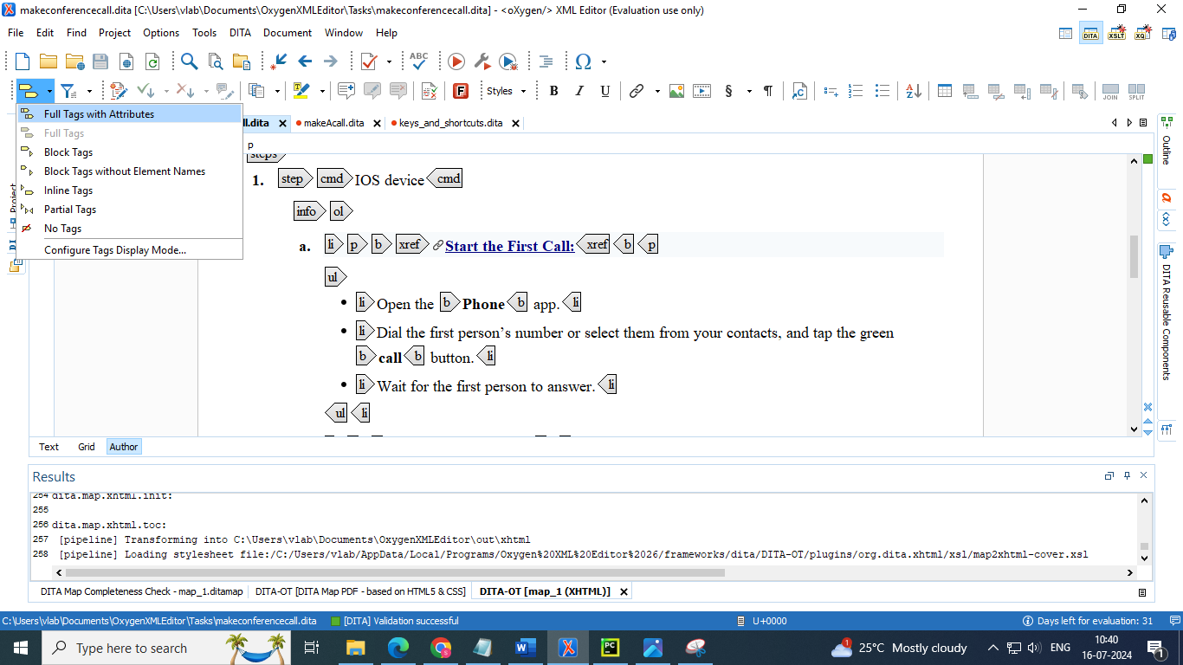

### **3.3.8 Adding steps in a topic**

* Press enter 🡪 select step from dropdown list

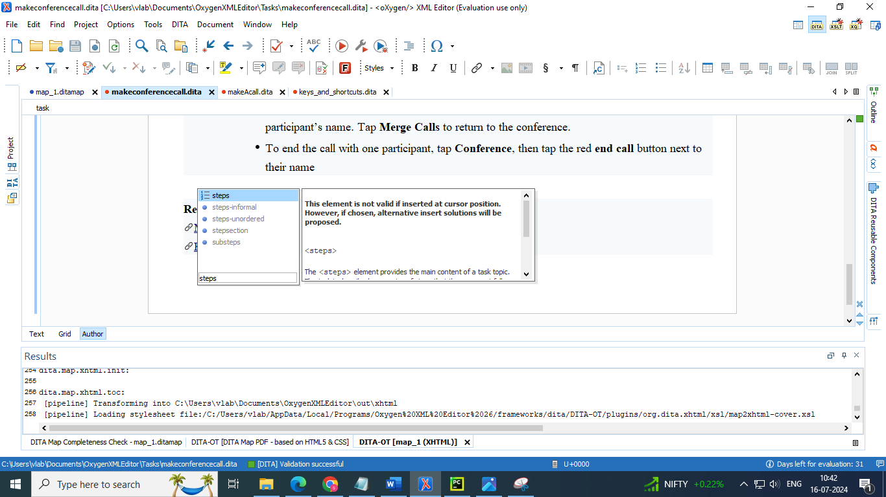

### 3.3.9 Adding list items

* Ordered list
* Unordered list
* **Select from menu bar**



* Select from dropdown list after pressing enter
* ol – ordered list

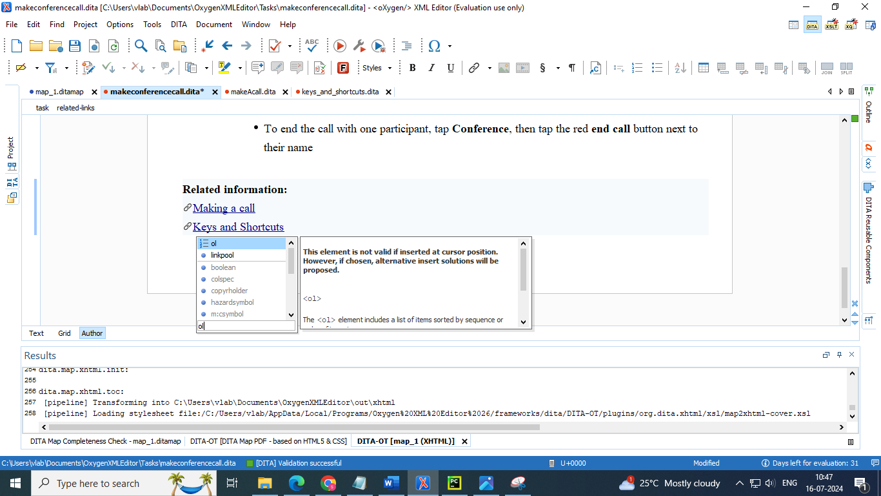

* ul – unordered list

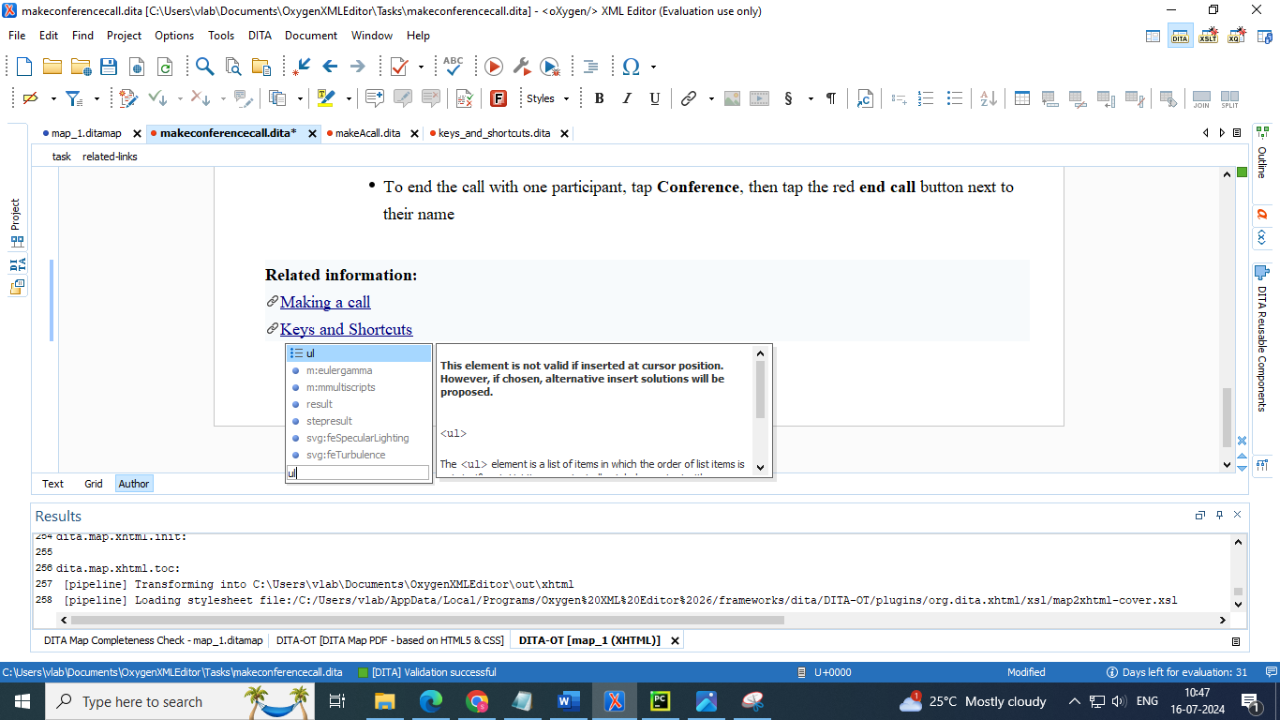

### 3.3.10 inserting images



* using an icon on menu bar
* use DITA resusable components tap to :
* drag and drop image (or)
* right click and select from dropdown list.

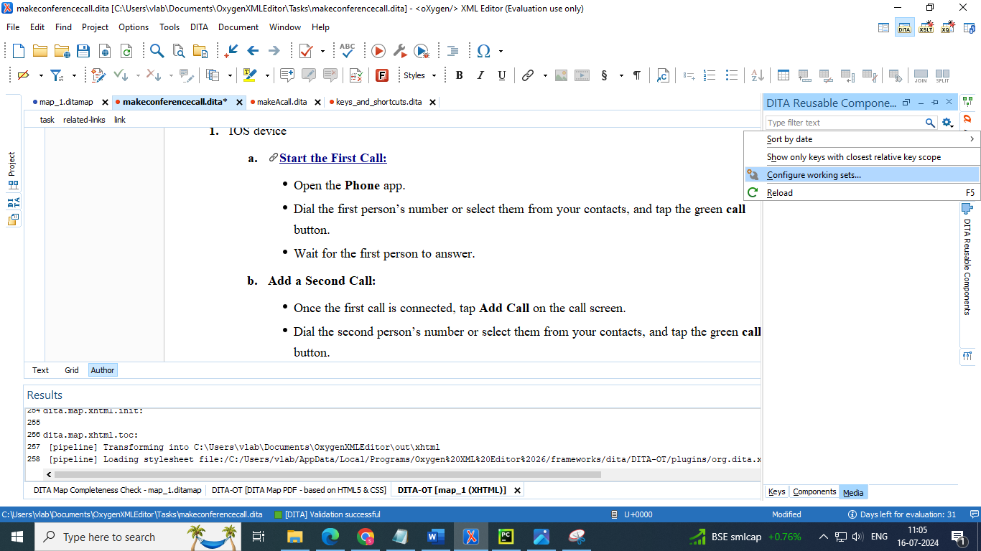

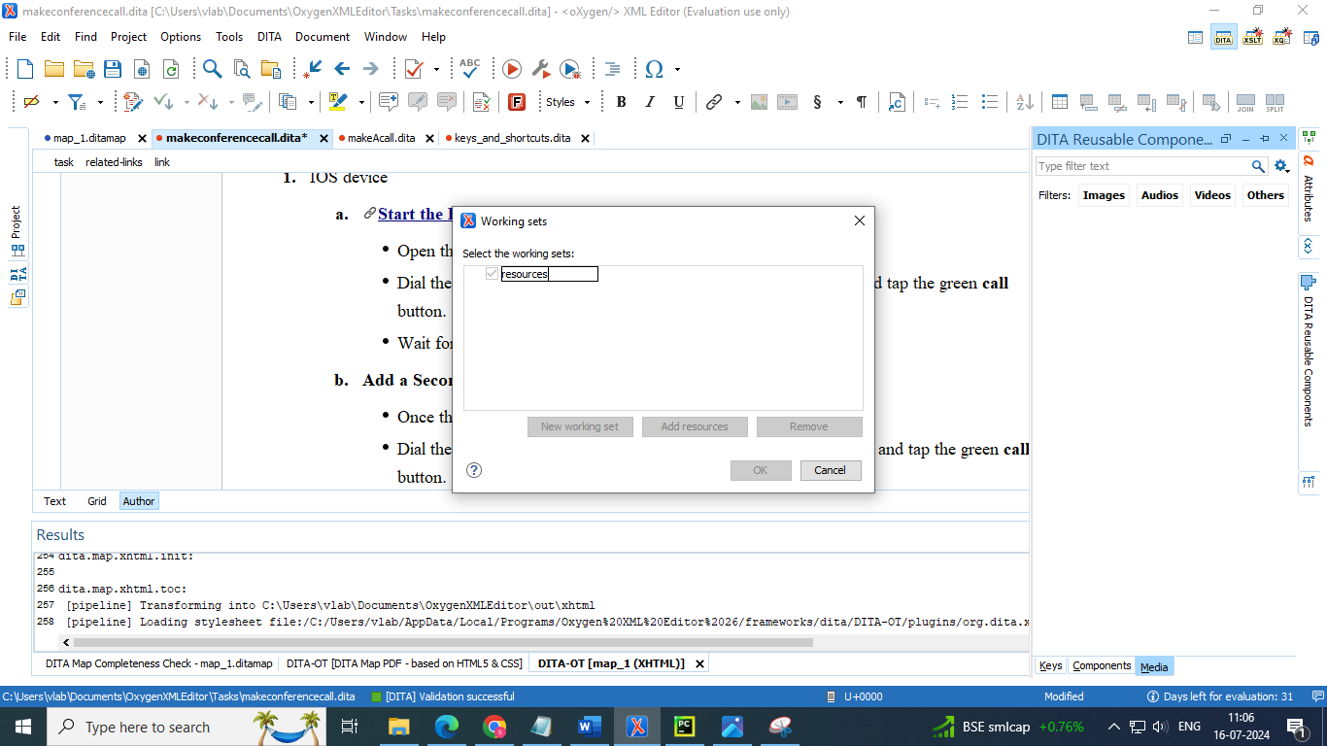

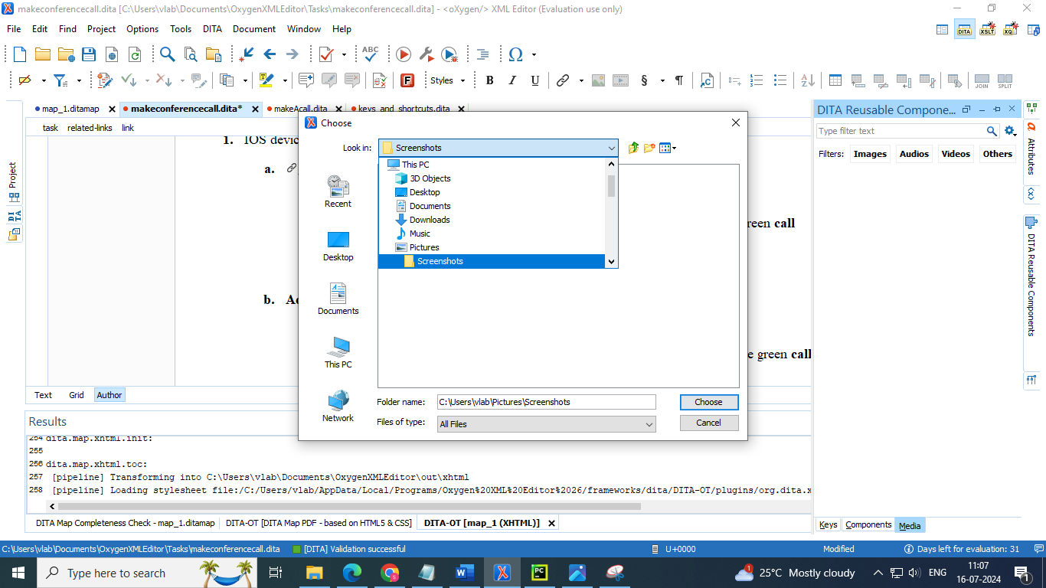

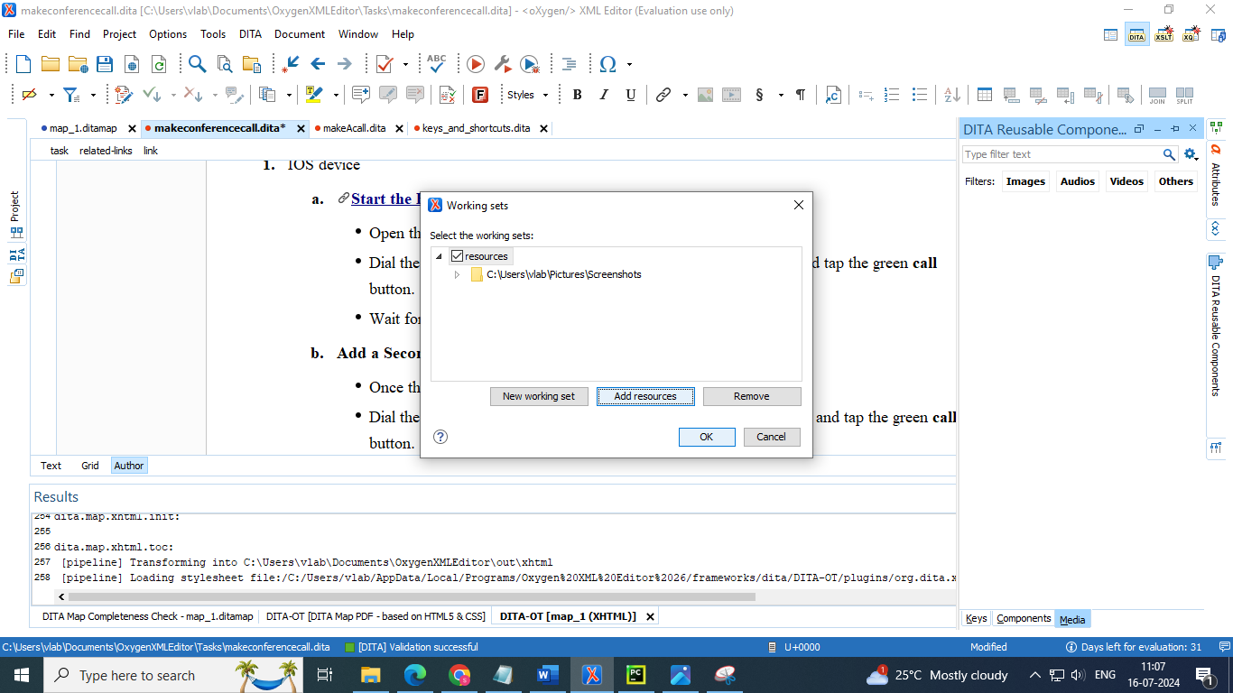

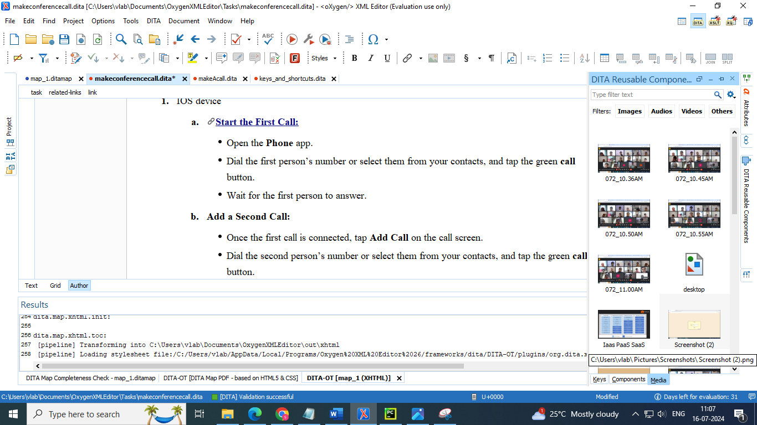

* here images can be inserted in 3 formats

1. link
2. reference
3. figure with title

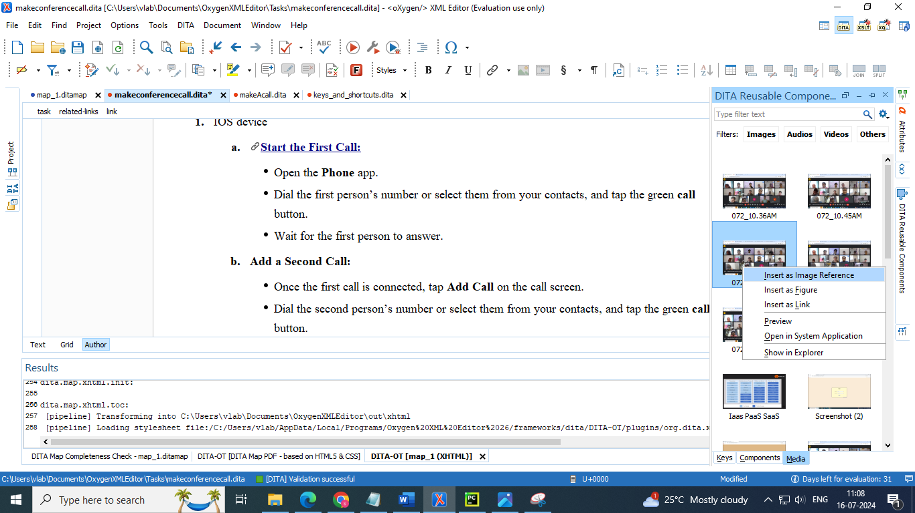

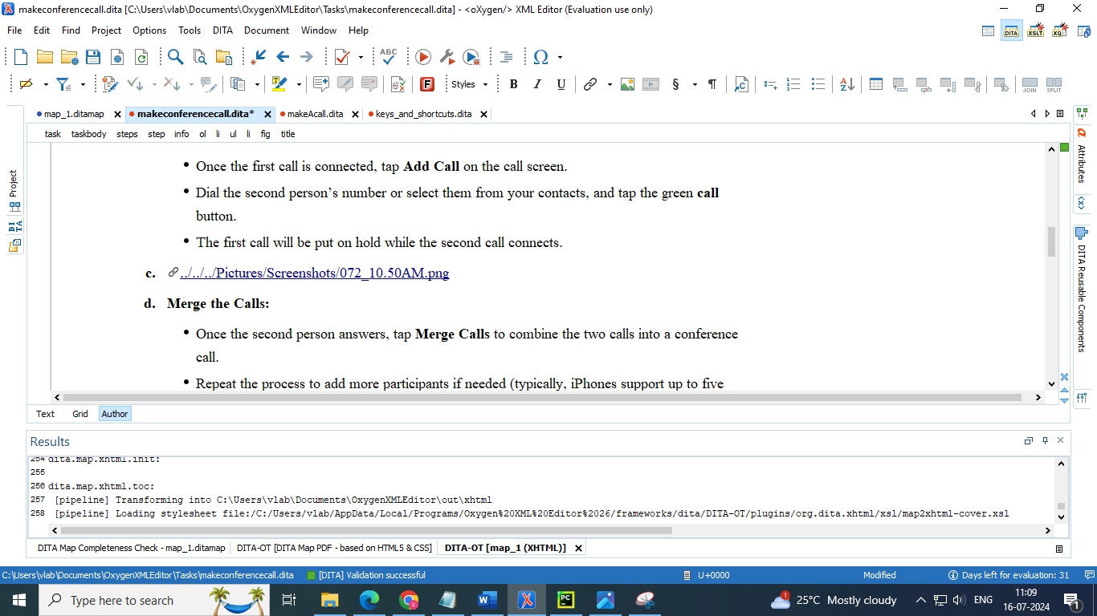

* editing the attributes of the image

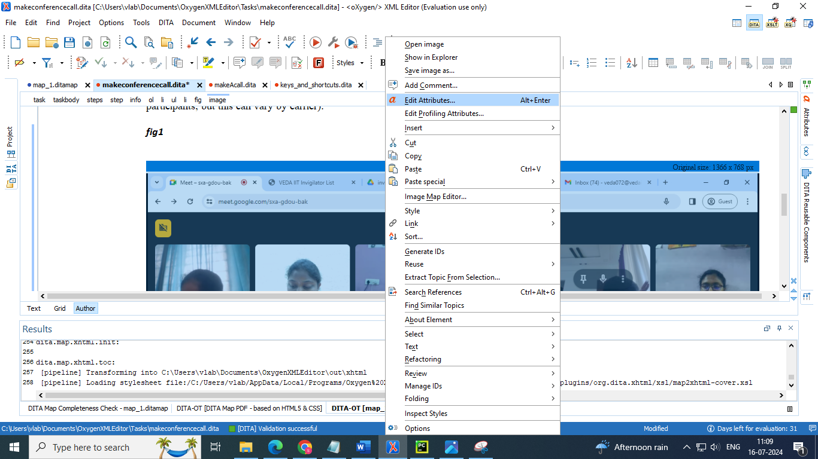

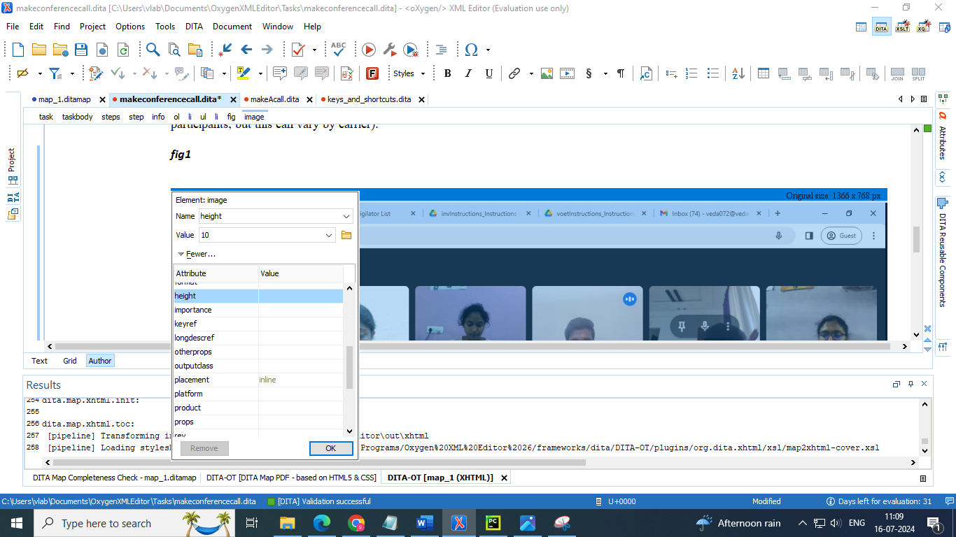

### 3.3.11 inserting video

* go to DITA reusable components
* add the required video folder to it same as image folder adding process
* insert it as link or reference

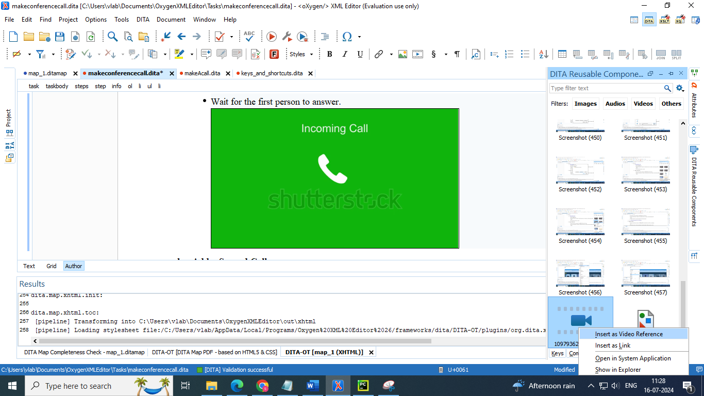

### 3.3.12 Adding critical dates like “created”

* press enter 🡪 select prolog 🡪 press enter 🡪 select critdates 🡪 press enter 🡪 select created

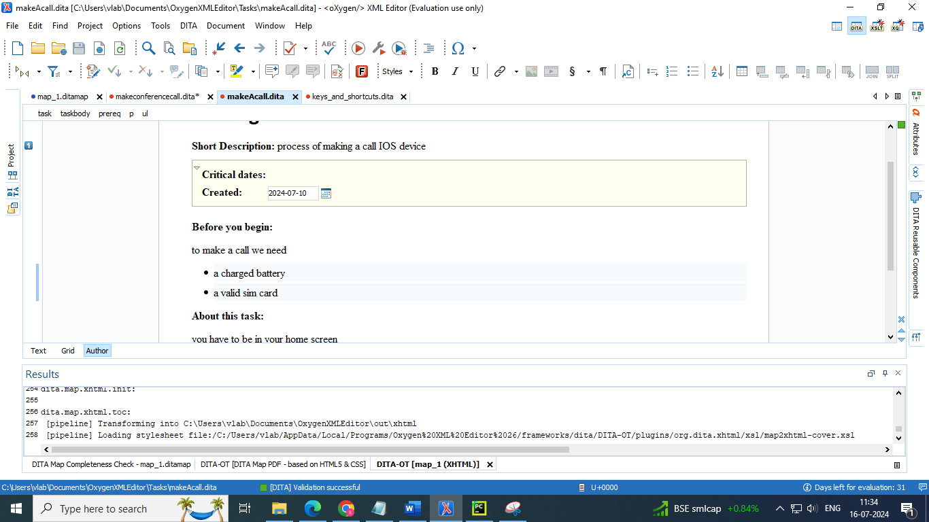

## 3.4 Validate and check for completeness

* You should validate your DITA maps regularly to make sure your maps and topics are valid, all of the relationships between them are working, there are no unreferenced reusables, etc.
* The DITA Maps Manager provides validation and completeness checking for the entire topic hierarchy of a DITA map through the Validate and Check for Completeness action
* Just as it is with your individual topics, it is important to validate your maps. Oxygen XML Editor provides a validation function for DITA maps that does more than simply validating that the XML is wellformed. It also does the following:
  + Validates all of the relationships defined in the maps.
  + Validates all of the files that are included in the map.
  + Validates all of the links that are expressed in the files.
* Validating the map that describes your entire publication validates all the files that make up the publication and all of the relationships between them.
* To validate a map:

1. Click the Validate and Check for Completeness button in the DITA Maps Manager view

**Step Result**: This opens the DITA Map Completeness Check dialog box .

2. Select any of the various options you want to check.

3. Click Check to run the validation process.

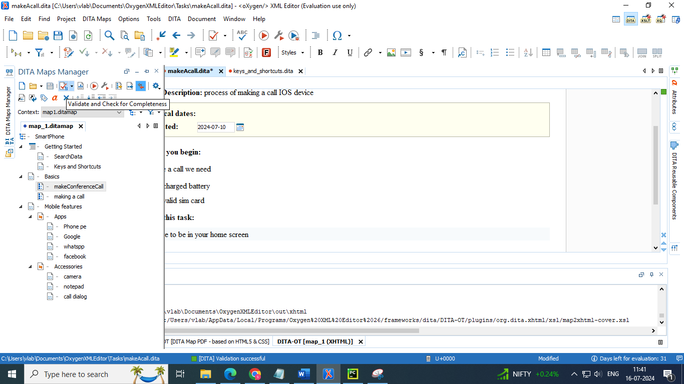

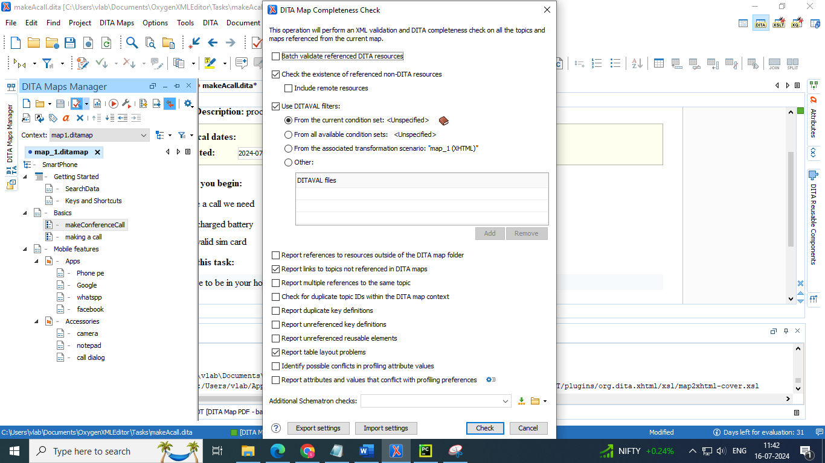

* additional schematron checks is to add your custom check rules

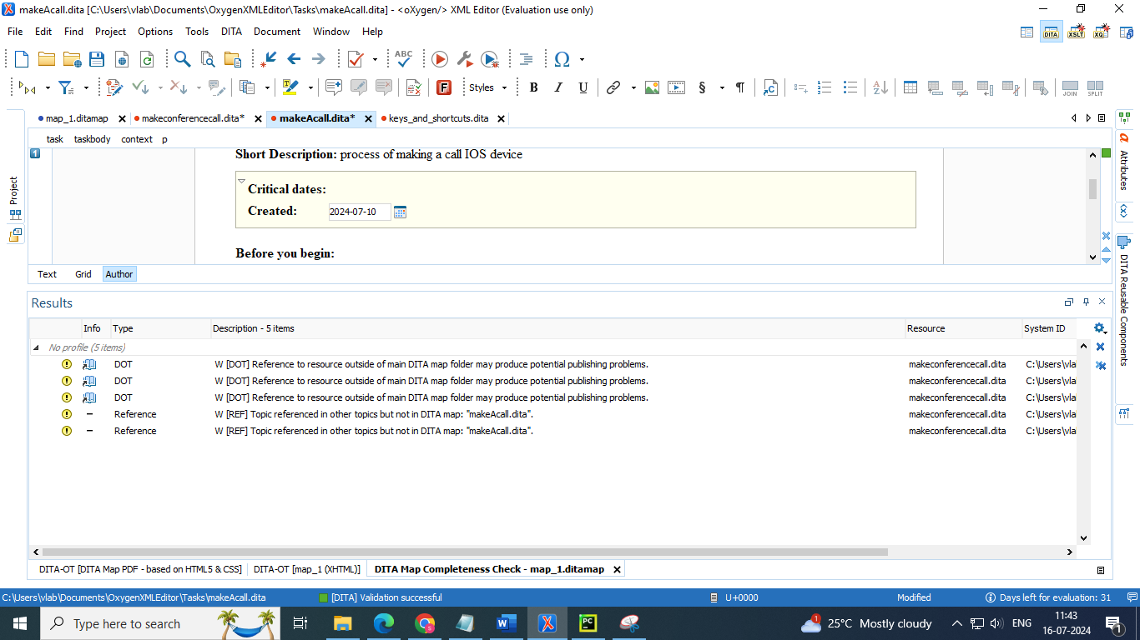

## 3.5 Publish

* Oxygen XML Editor publishes DITA content to various output formats using a bundled version of the DITA Open Toolkit (DITA-OT).
* The DITA-OT is an open-source, plugin-based publishing engine, and can publish DITA content to formats such as XHTML, PDF, Windows Help (CHM) and others.
* The DITA-OT that comes bundled with Oxygen contains additional plugins than enable converting DITA content to Word, EPUB, WebHelp, or publishing to PDF using CSS for customizing the output
* As noted previously, in DITA standards you usually do not publish output from an individual topic. Instead, you create published output by running a DITA transformation on a map. This collects all the topics that are referenced in the map, organizes them, and produces output in a particular format.By default, Oxygen XML Editor uses the transformations provided by the DITA Open Toolkit for publishing to various output formats (such as PDF, WebHelp or EPUB). Your organization may have created various custom transformations or modified the built-in DITA Open Toolkit transformations. In either case, Oxygen XML Editor manages them by using transformation scenarios.
* To publish output for a map:

1. Click the Configure Transformation Scenario(s) button in the DITA Maps Manager view Step Result: This opens the Configure Transformation Scenario(s) dialog box (on page 1600).

2. Select the appropriate transformation depending on the type of output you desire.

3. To change or view the configuration or storage options for a transformation scenario, select the transformation and click Edit.

4. Click Apply associated.

**Result**: Depending on the configuration of the transformation scenario, when the transformation is finished, your output may automatically be opened in the appropriate application.

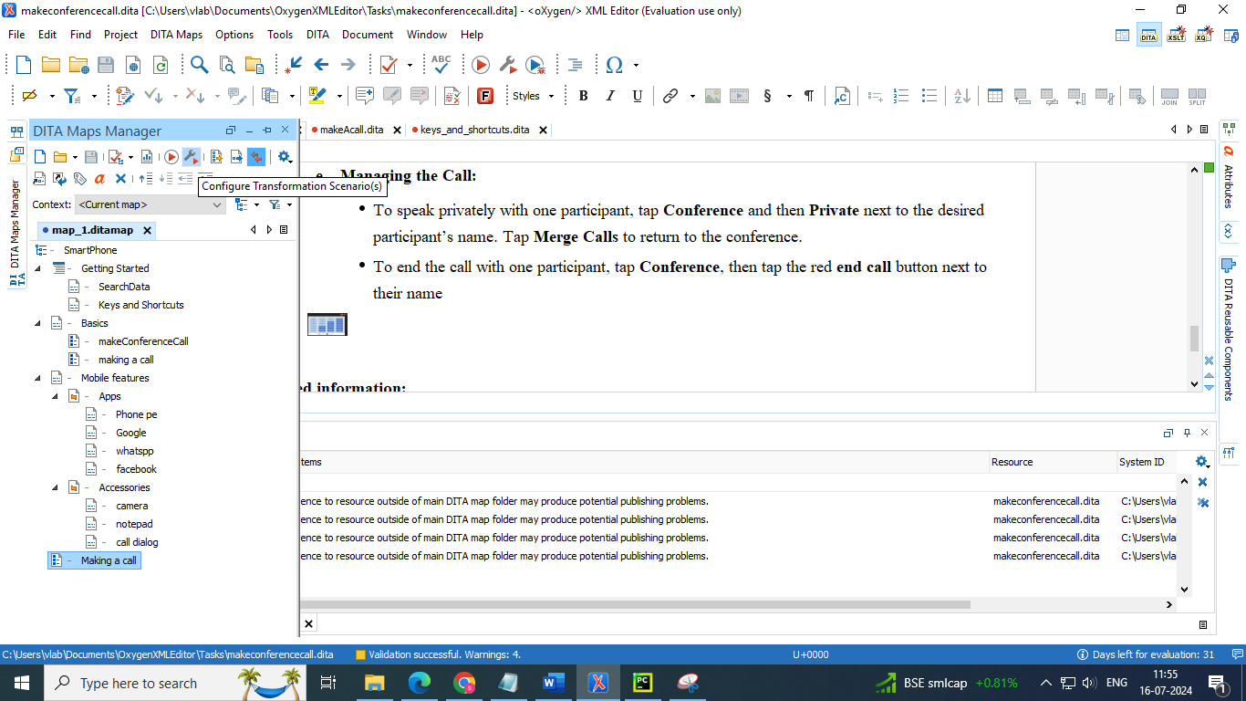

* Select the required type of output you want to generate

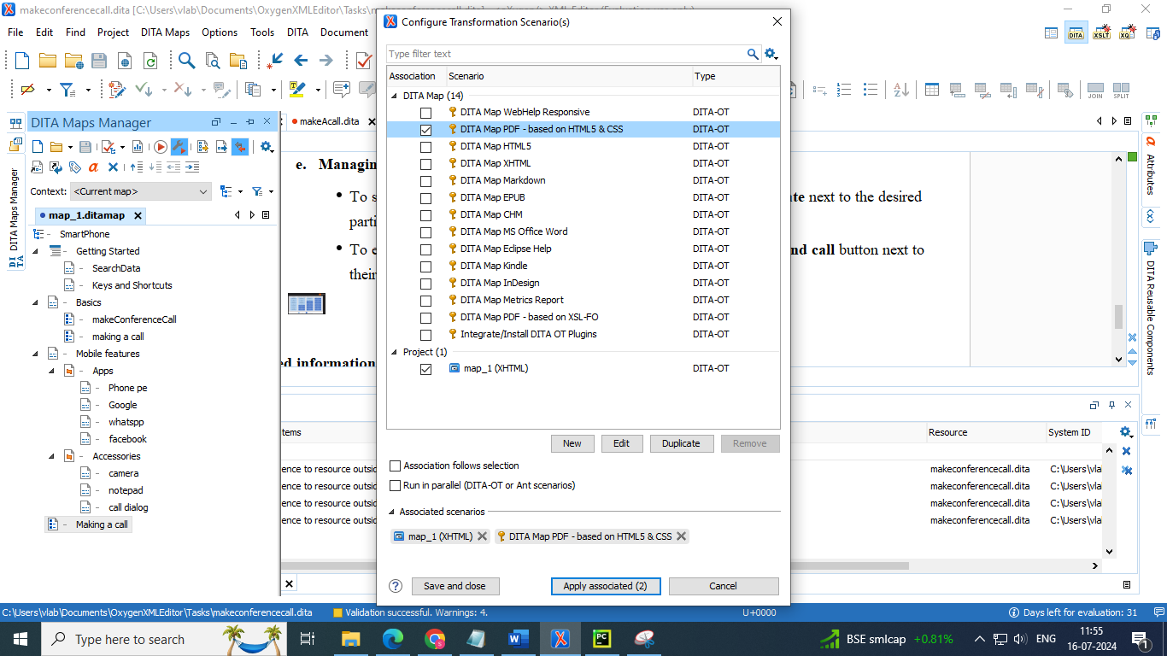

* Press edit button to set your required template

